Deborah Barndt

Lab 4: Parser

ITMD 455-02

3-15-17

Snapshot Login 1- bad attempt:

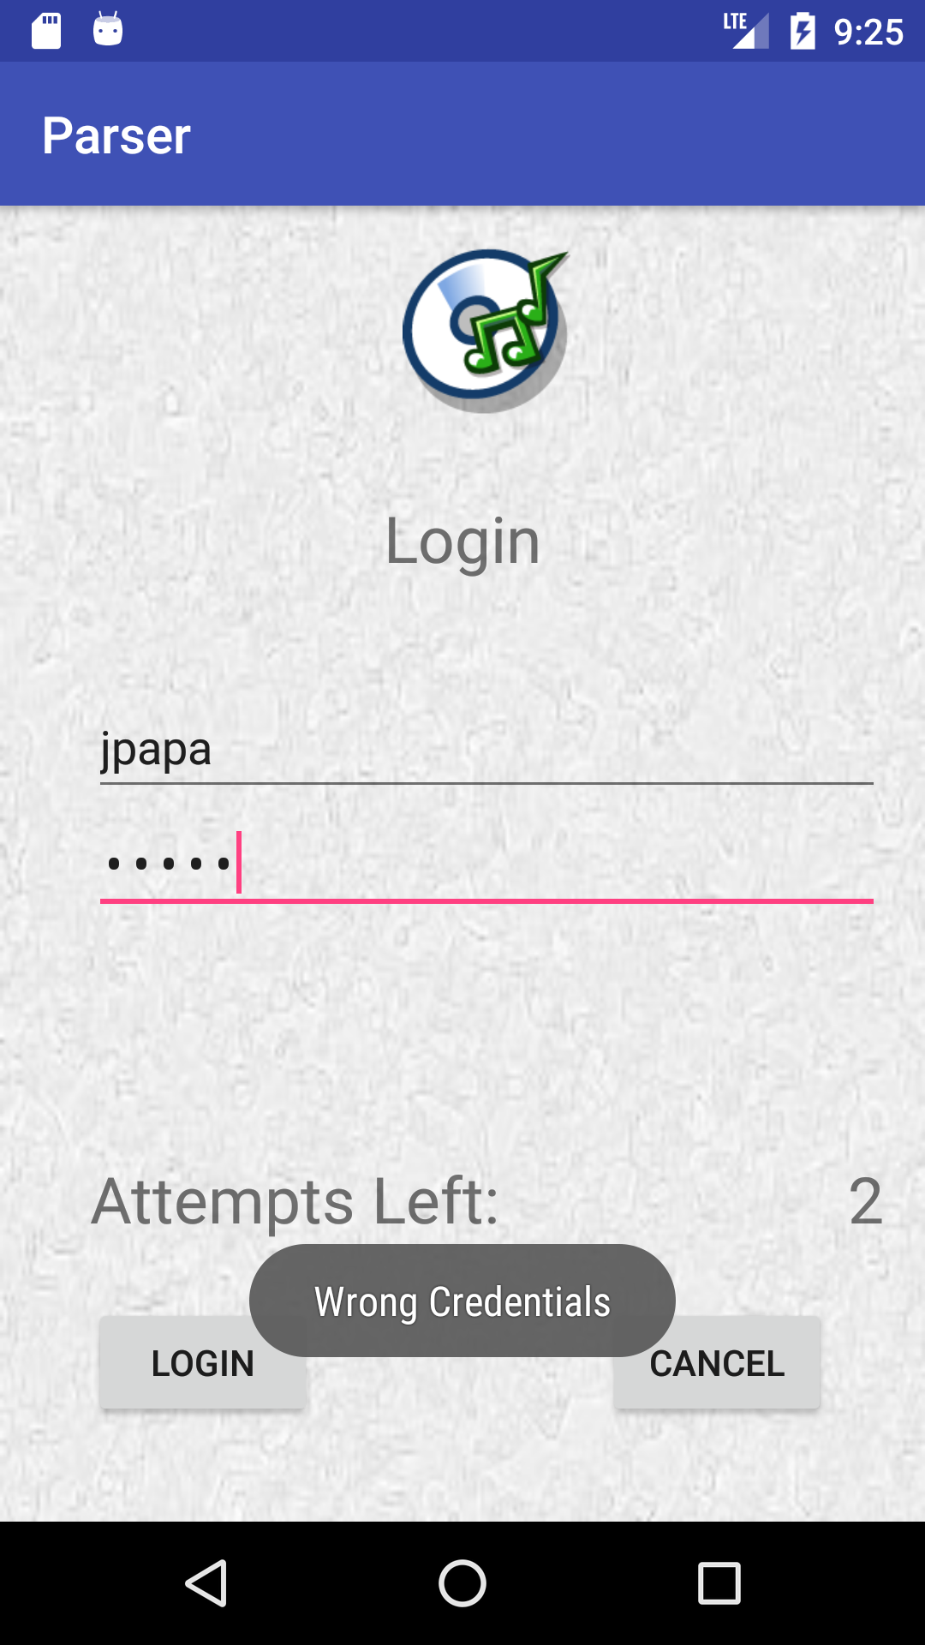

Snapshot Login- 2 Successful Image 1

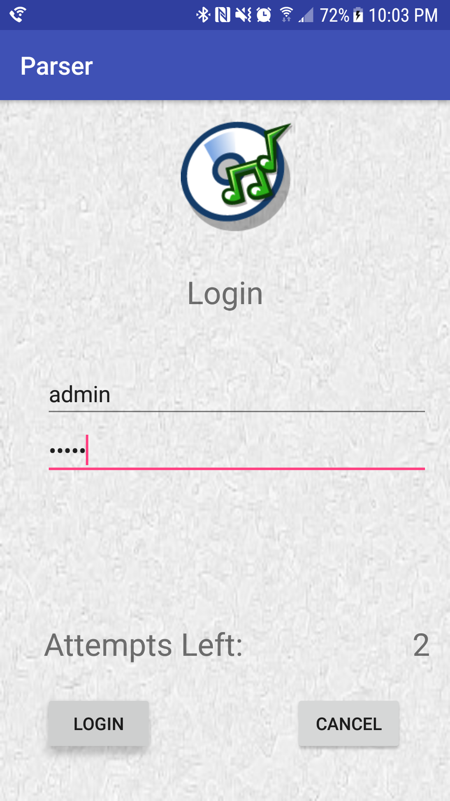

Snapshot Login-2 Successful Image 2

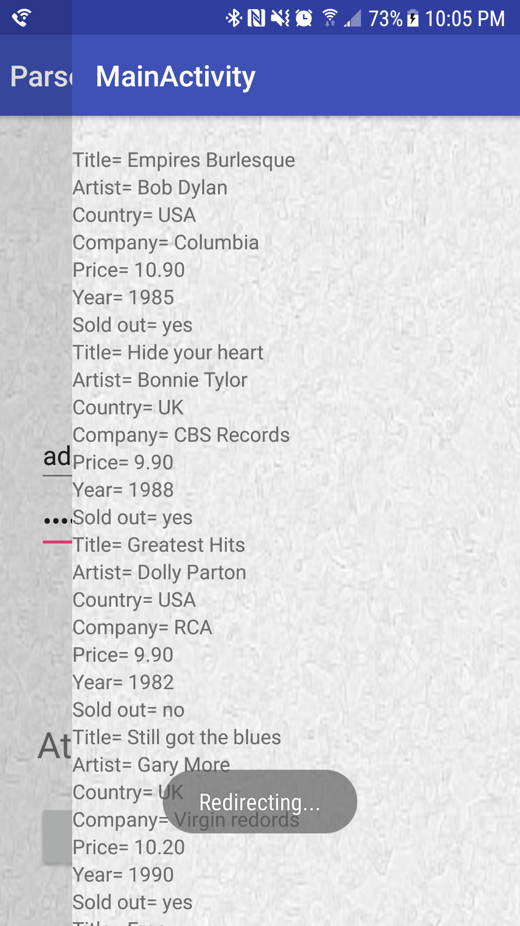

Snapshot XML data 1:

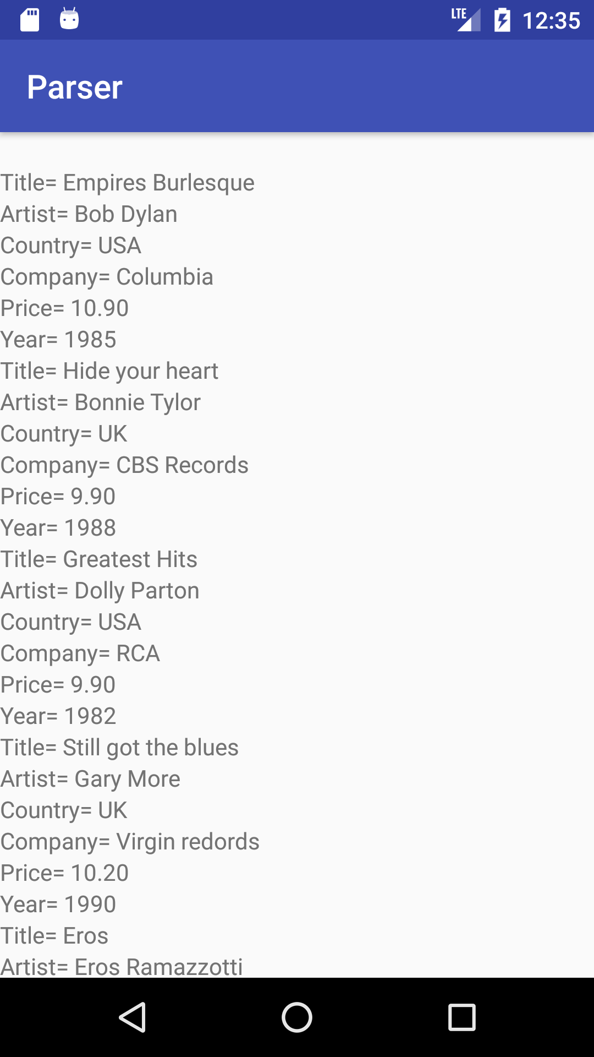

Snapshot XML Data 2:

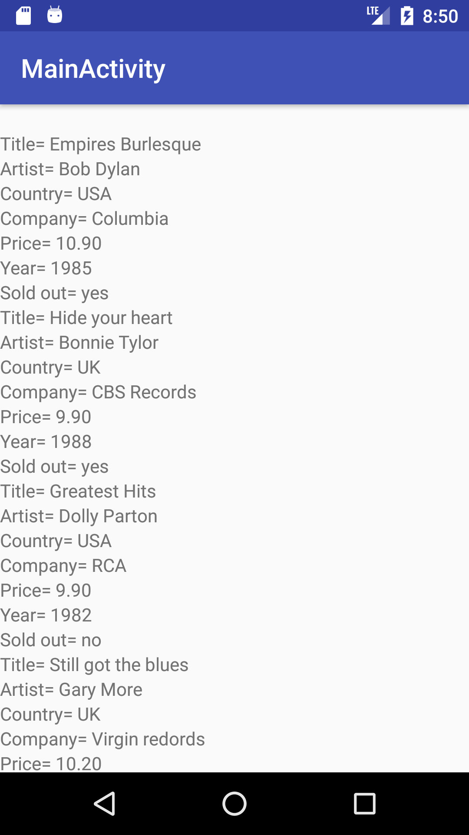

Snapshot XML Data 3:

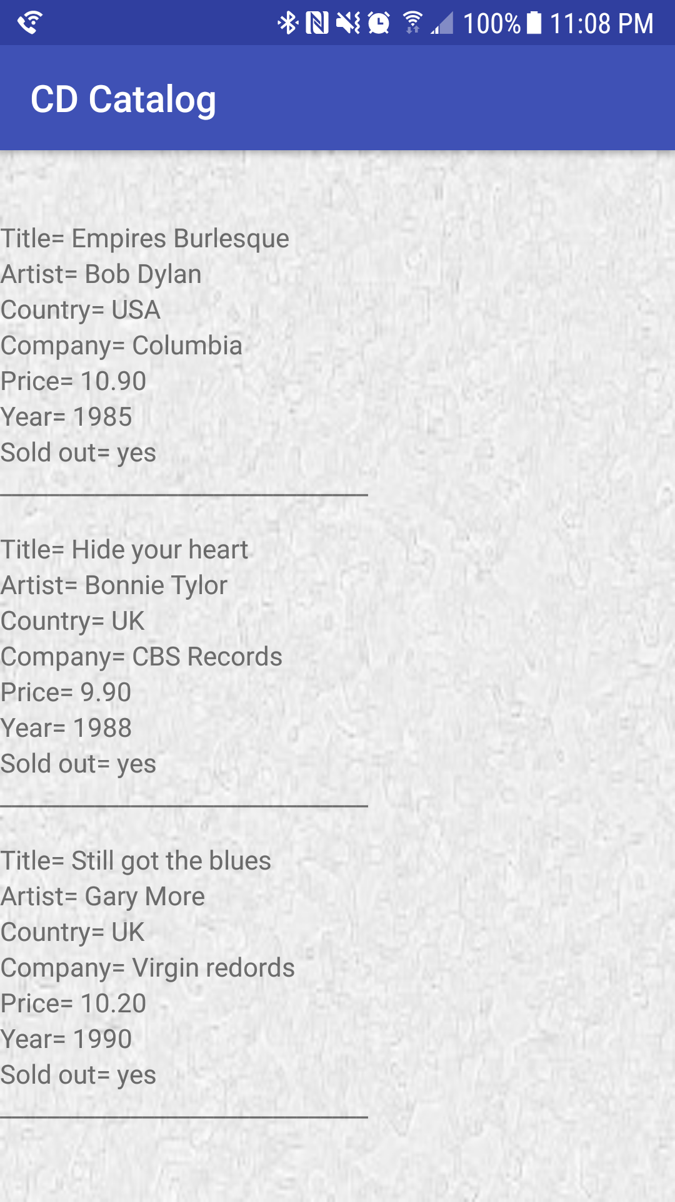

Snapshot of Parser App Icon:

